**Use cases**

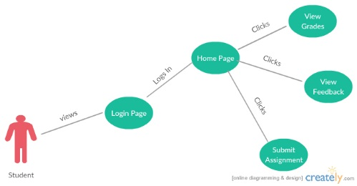

Use Case Diagram 1: Student Login & Assignment submission

1. Initially, the student view the login page and enters his user credentials
2. The user credentials are validated and then he is directed to the Home page
3. The User can perform three actions at this stage. He can either view the grades and feedback of a previous assignment or take a look at the new assignment and submit this new assignment

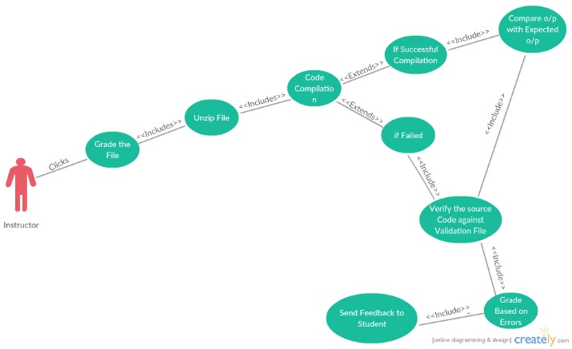

Use Case Diagram 2: Instructor Grading the Assignment

1. Initially, the instructor clicks on Grade button
2. The assignment zip file is unzipped automatically
3. The source code from the unzipped file is then tested for compilation
4. The program will either successfully compile or fails compilation
5. If the code is compiled successfully, the code is executed and the output generated is compared with expected output
6. It is then verified against the validation file which contains the rubric for various test cases
7. Grade is generated based on the number of test cases passed and the number of errors generated.
8. A feedback in the form of an excel file is sent to the student
9. In case the compilation fails, repeat step 6
10. A deduction of 50% of the total scores and Repeat step 7 & 8